SUMMER 2026 UPDATE
Investor Update: The Right to Know AI Is Now in Beta
A working iPhone beta, 834 women on the waitlist, real-user feedback, and a clear next step toward public launch.
10  current beta testers | 834  women on the waitlist | $225K  established next raise | ASAP  target launch

A major milestone for our investors
Right to Know now has a functional beta version of its women's health AI. Ten women are actively testing the app in daily life, their feedback has already led to meaningful updates, and 834 women have joined the waitlist. For current investors, this is visible progress from concept to working technology. For prospective investors, it is an opportunity to help move a validated product toward public launch.
This is no longer only an idea. Women are using the beta, asking questions, logging health information, and receiving personalized support.

What the beta can do today
- Personal AI conversation: Users can ask questions about their cycle, mood, nutrition, symptoms, and overall well-being.
- Whole-body tracking: The app brings together information such as mood, exercise, meals, sleep, basal temperature, cervical mucus, hydration, symptoms, medicine, and weight.
- Cycle-aware guidance: It displays cycle status and uses the information a woman logs to offer context that reflects where she may be in her cycle.
- Useful reports: Users can review their information and generate a monthly PDF designed to help them share a fuller health picture with a medical professional.

THE BETA IN ACTION
Designed to help a woman see the full story her body is telling
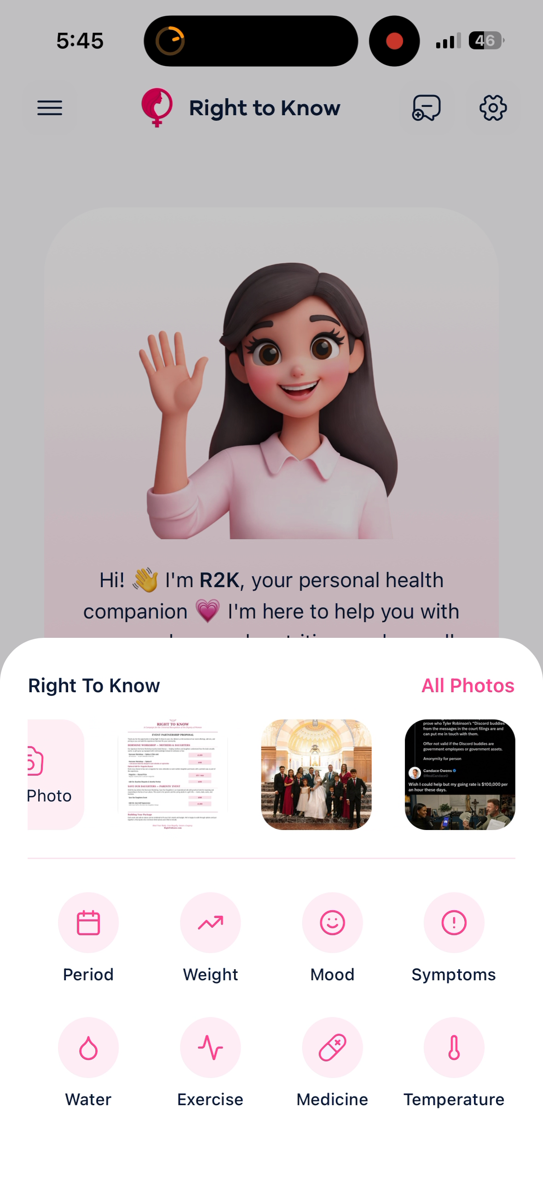  A personal health companion for everyday questions | 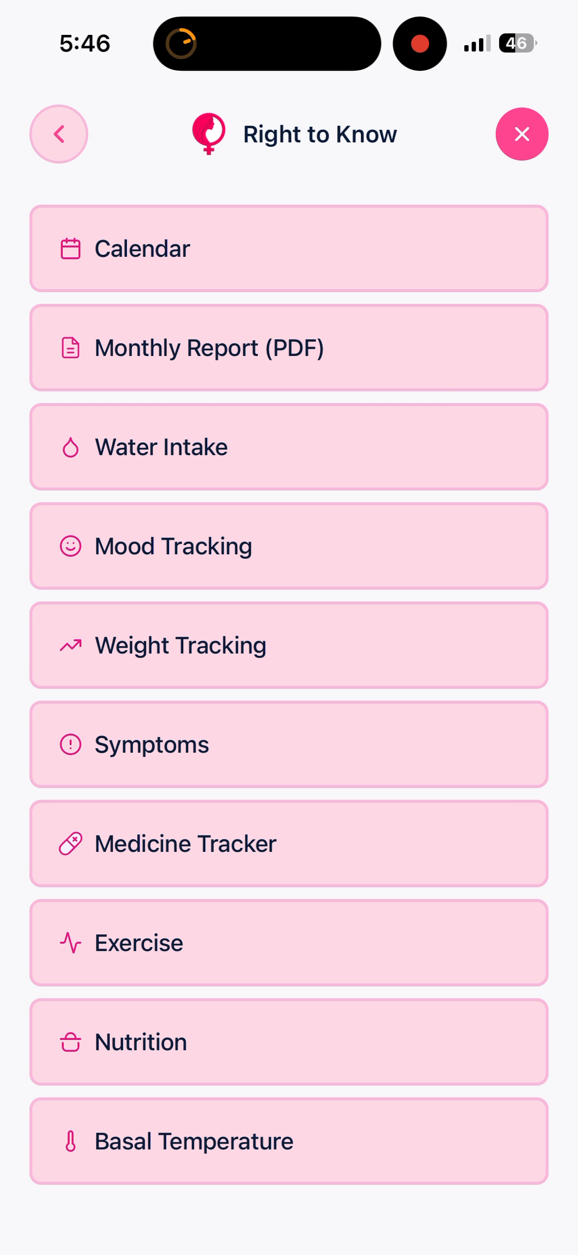  Tracking and reports that make health patterns easier to see

What the next $225,000 makes possible
The pitch deck establishes a $225,000 next raise to move from a limited beta to a public-ready product. This funding will support:
- continued development and expansion of the app's capabilities;
- a more intuitive, polished, and welcoming user interface;
- the updates identified through real-world beta testing; and
- the technical work required to prepare the app for public release.
Our target is to launch as soon as the product and funding allow. This next investment closes the gap between a working beta and a tool that can serve women at scale.

Why this work matters
The organization that earns a girl's trust when she first asks questions about her body may become the one she turns to when she is in pain, afraid, or facing an unexpected pregnancy. Right to Know is working to earn that trust earlier through body literacy and care that recognizes the dignity of women and their children.
Our vision also includes connecting users with medical professionals and pregnancy centers that meet the Right to Know Standard of Approval. Supporting this technology helps build a life-affirming alternative that can accompany women before a crisis and throughout their health journeys.
Help us take the next step
We are welcoming five additional women to test the iPhone beta and seeking partners who can help complete the established $225,000 next raise.
Join the beta through TestFlight | Learn more at righttoknow.com

THE INVESTMENT CASE
Building the trusted women's health brand for the next generation
$3.2B  women's health app market, 2022 | 19.6%  projected CAGR through 2030 | 834  women currently on the waitlist | 35K+  monthly views; some months 300K+

A market asking for a better answer
Gen Z women are already searching online for health guidance, while many existing apps simply record data or fertility events. Right to Know combines education, protected data, pattern recognition, and access to trusted care.

Traction before public launch
- Spring 2026 outreach reached approximately 3,200 students across 16 college campuses; the broader school presence also includes six high schools and four middle schools.
- Five hours of college-campus outreach generated more than 200 initial AI waitlist sign-ups; the waitlist has now grown to 834 women.
- Social-media content consistently receives more than 35,000 views per month, with some months exceeding 300,000.
- The medical advisory board includes 35 doctors and is supported by Dr. John Bruchalski.

What current investor capital has built
- A functional iPhone beta with AI conversation, whole-body logging, cycle-aware guidance, reports, and real-user testing.
- Social-media content consistently reaching more than 35,000 views per month - with some months exceeding 300,000 - alongside campus outreach and an 834-woman waitlist.
- A medical advisory board of 35 doctors, supported by Dr. John Bruchalski, to help anchor the platform in medical integrity.
- A trust-first ecosystem that includes the magazine, schools, workshops, community programs, and an emerging approved-care network.

Why Right to Know can win
- Trust-first acquisition through campuses, workshops, in-person education, and future national bus outreach.
- An integrated ecosystem of AI, magazines, schools, community programs, approved clinicians, and pregnancy-center partnerships.
- Text, voice, and image inputs; body literacy; pattern recognition; reports; and connection to approved care.

THE NEXT STAGE
The next $225,000: from working beta to public launch

Business model and growth thesis
The planned freemium model offers a $6 monthly premium tier and assumes approximately 6% conversion, below the 8-12% benchmark cited in the deck. The model excludes upside from higher tiers, clinician-network revenue, workshops, international growth, and ARPU expansion.

Established founding raise
The investor deck establishes a $350,000 founding raise for 12% total equity. The full capital plan is allocated as follows:
- $190,000 - AI development, infrastructure, safety testing, data systems, integrations, and user-driven iteration.
- $65,000 - Corporate structure, investor documentation, privacy, compliance, governance, and mission protection.
- $95,000 - Leadership, medical-reviewed content, user testing, marketing, and go-to-market execution.

The current standstill - and the next inflection point
Right to Know has reached a working beta and demonstrated demand, but development is currently at a standstill until the next capital is raised. Completing the established $225,000 next raise restarts development and moves the product toward public release. Priorities include:
- AI development, infrastructure, safety testing, and interface improvements;
- privacy, legal, compliance, governance, and secure data-sharing readiness; and
- clinician integration, medical-reviewed content, marketing, and launch preparation.

Near-term milestones
Expand the beta from 10 to 15 women; refine the interface and underlying technology; prepare approved-care integrations and medical-reviewed content; and release publicly as soon as the product and funding allow.

A durable, mission-protected company
Right to Know is being built for long-term ownership rather than a required sale. Its structure pairs investor participation with reinvestment, mission allocation, and governance that protects the company's purpose. Detailed terms and illustrative scenarios are available in the full deck and governing documents.
An invitation to build with us
Current investors: thank you for helping us reach this milestone. Prospective investors: we welcome opportunities to present Right to Know and discuss participation in the established $225,000 next raise.
Projections and assumptions are illustrative and are not guarantees of future performance.

